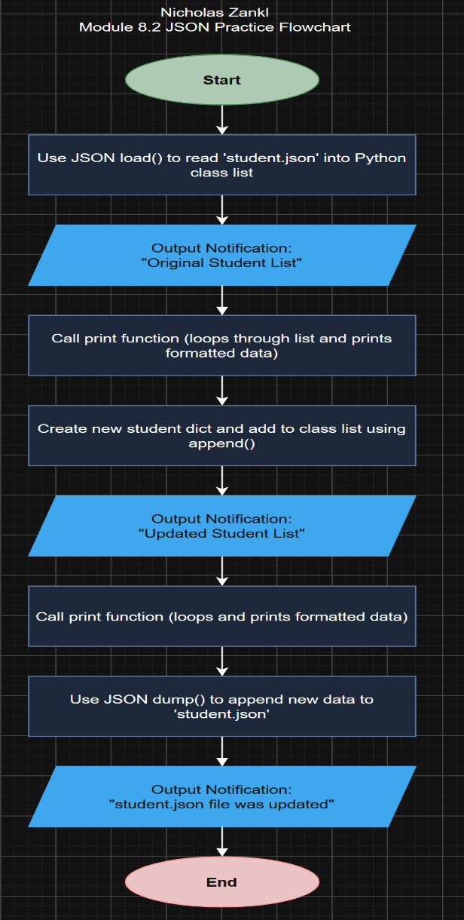
Preface and Project Overview

For the purposes of convenience, I decided to temporarily put the “module-8” directory onto my desktop while I tested the codes. The final deliverable will follow the required file structure for the GitHub submission.
This project demonstrates the core workflow for reading, processing, and modifying structured JSON data using Python file handling and object manipulation. The application opens an external JSON data file containing student records, loads the structured array into memory, formats and displays the initial dataset, appends a new record dynamically, and exports the updated dataset back to the physical file system. The core logic follows a standardized, sequential pipeline designed for seamless data persistence and auditability. Initially, the script ingests student.json using the json.load() method, converting the raw JSON array into a native Python list of dictionaries. A custom output function iterates over the dataset to render a cleanly formatted text view of each record.

Figure 1: Program Logic and Execution Flowchart

Figure 2: Terminal Output Execution
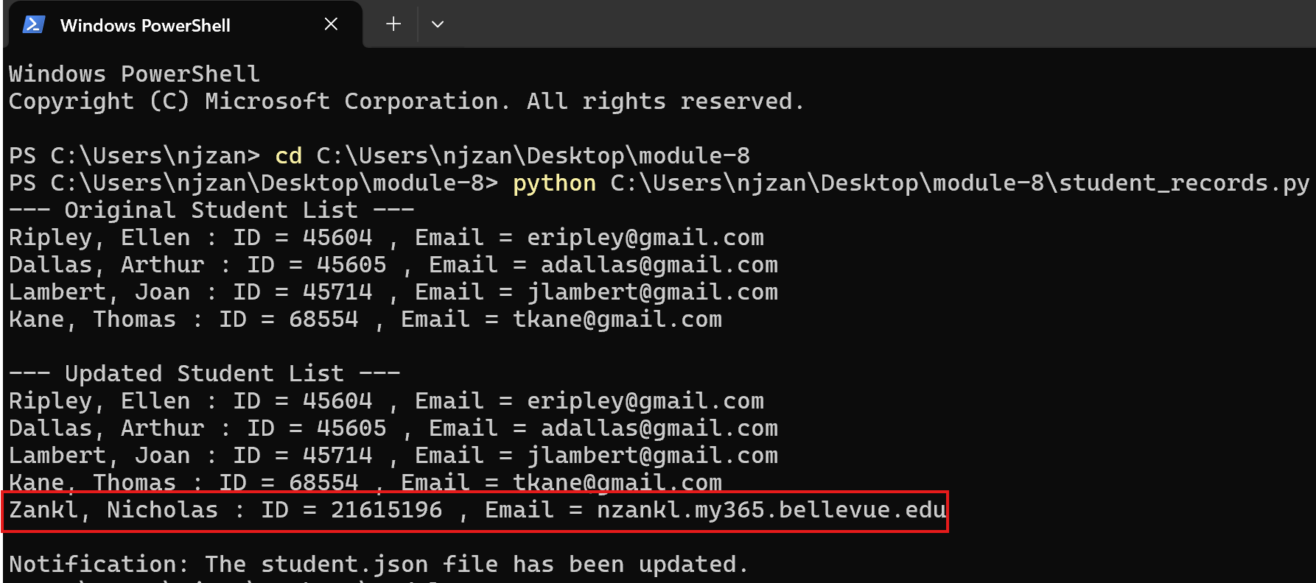
Following the initial display, a new student dictionary object containing customized full name, unique student ID, and email parameters is appended directly into the active Python class list using standard list operations. The updated dataset is reprinted to verify state changes before json.dump() serializes the structure with 4-space indentation back to student.json, prompting an editor notification confirming file modification.
Figure 3: File Modification Alert
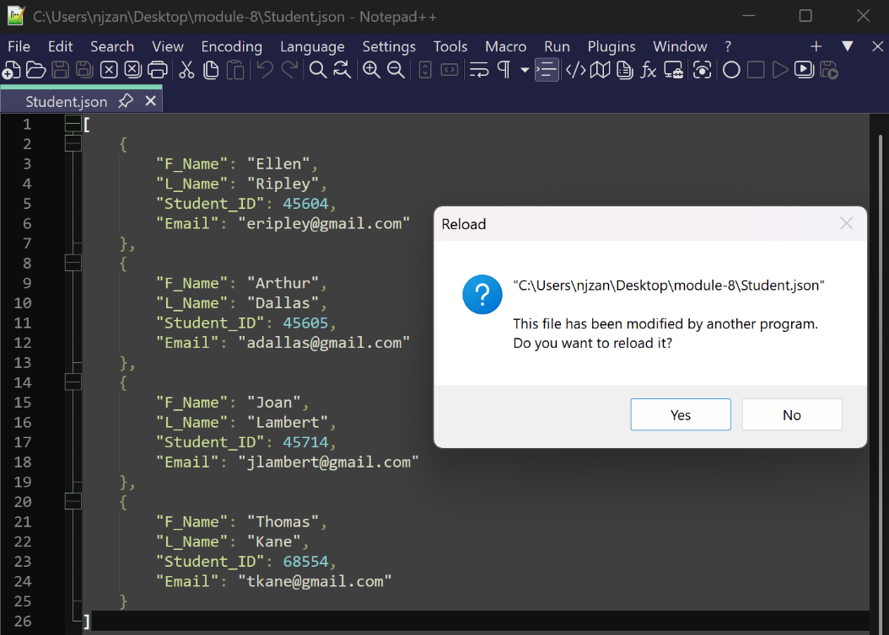
If the user clicks “No” on the reload prompt, the unmodified code remains in the script editor (in this case Notepad++) and nothing else happens. However, if the user chooses to click “Yes” on the prompt, the code will reload with the added revisions to it.
Figure 4: student_records.py modified successfully.
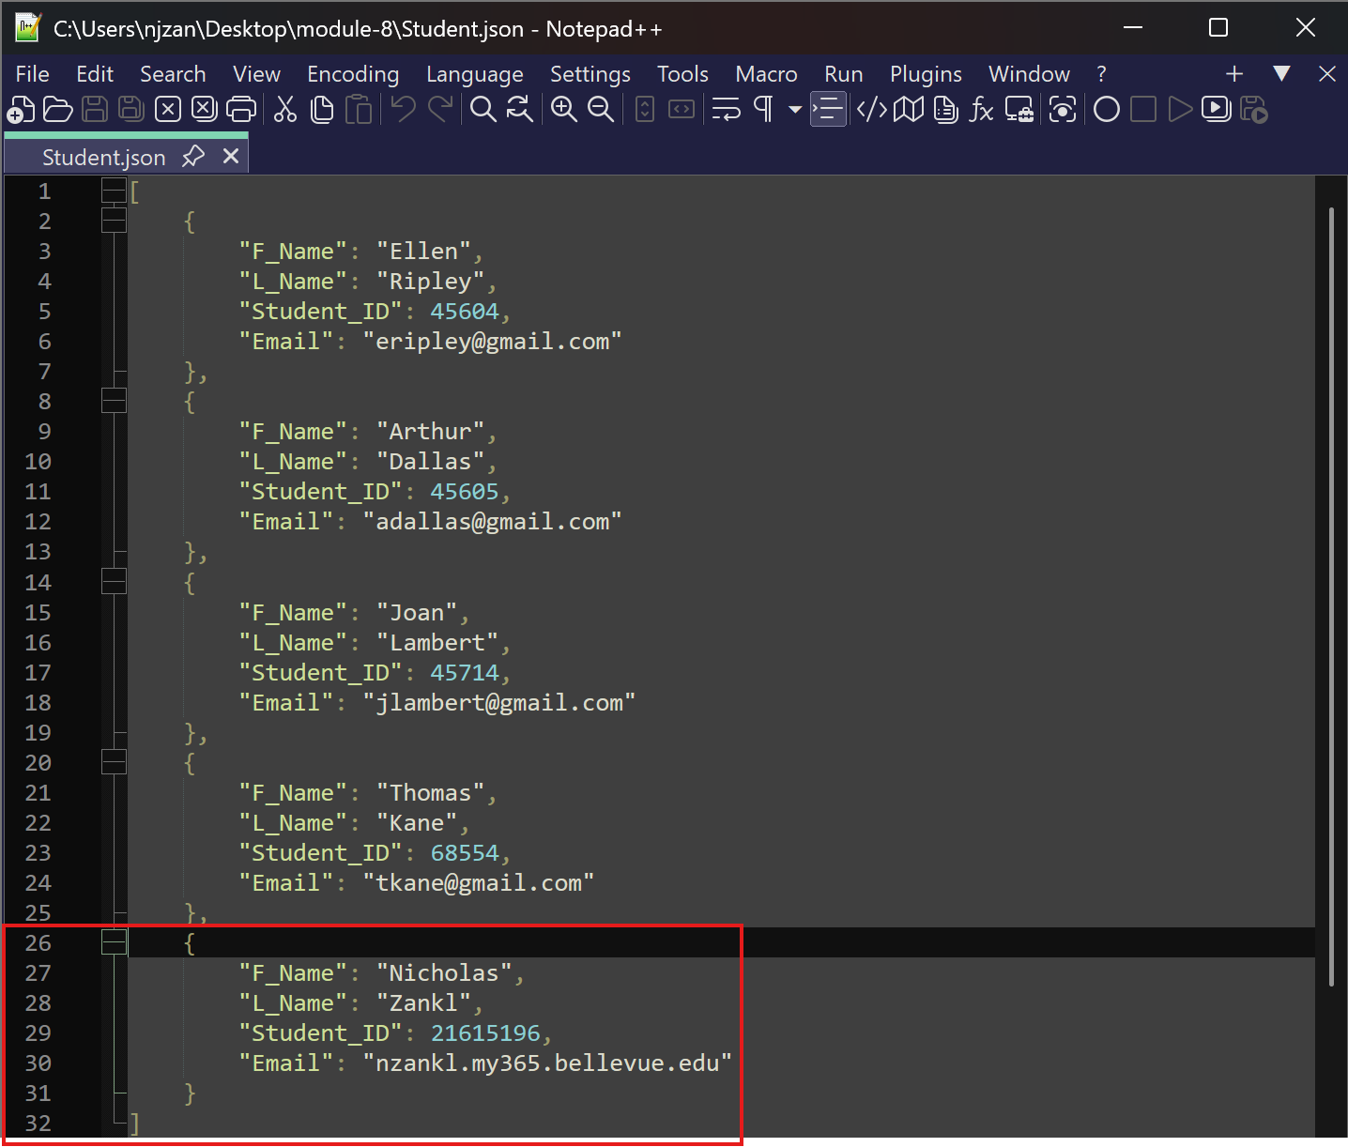
This is a clever way that most IDE environments use to implement a minor error check that allows a developer to rollback a mistake they may have made.

